COEN 178 Intro to Database Systems Fall 2019

Lab 8 (50 pts)

Objectives: Learn
- Using HTML, PHP and Oracle SQL to build a Web application that reads the user input via an HTML form, processes the input on the server side using PHP and Oracle SQL.

Ref: https://www.oracle.com/technetwork/database/database-technologies/php/phpintro-otn-090860.html#t5

In this lab, you will work with different pieces in building a web application that uses an Oracle database. You will do the following:

- Create the tables and necessary PLSQL procedures/functions.
- Use an HTML web form to input the data that should be inserted into the tables in a)
Invoke a PHP script that takes the input data from the webform in b) and inserts it into the tables in a. You will learn how to call a PLSQL procedure from a PHP program.
- Use a web form with a clickable link to display the data in the tables.
Note: You will learn all the steps necessary to build a Web application with a GUI for your final project.
In Part 2, you will use the knowledge gained in Part 1, to build a simple Web-based GUI to provide input to the tables and display the output.

Create the table and PLSQL procedure below:

- Create table MovieReviews (movieName varchar(25), comments varchar(40));
- Create or Replace procedure addMovieReview (v_movieName IN varchar, v_comment IN varchar) AS
BEGIN
insert into MovieReviews values (v_movieName,v_comment);
END;
/
Exercise 1 (15pts)
In this exercise, you will use an HTML web form for user input and a PHP script on the server side that processes the input and inserts the input into the tables, MovieReviews.
You will use the following files:
- movieReviewsForm.html
- addMovieReview.php
- showMovieStats.php
- Copy all the files into your webpages directory (/webpages/<username>/)
- Open the movieReviewsForm.html with your text editor and give the correct path to your addMovieReview.php script, in the action attribute of the form. Save your changes.
- Now, open the addMovieReview.php file with your text editor. Edit the code to put your username and password to login to Oracle database . Note: At the end of the lab session, please feel free to change your password.

- From your browser window, using its URL, open movieReviewsForm.html.

You should see a form shown below.
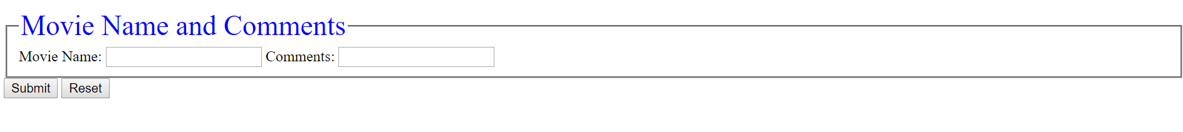This is the input form to insert data into the MovieReviews table.

- Enter the name of a movie you have seen and your comments in the fields in the form. Click submit button.
- Do you see any messages whether your submission succeeded? You should see the message below displayed on the page.
Movie Review Inserted
- Now, from your SQLPlus prompt, do a select * on MovieReviews table and check if the data you submitted via the form is inserted into the table. If the table does not show any data, give it a second or so, and do the query again. Sometimes, there is a lag time before you see the data. You may log out of SQL and log back on and try the query.
- Enter a few more rows of data (movie names and comments) into the tables, using the HTML form. You should do several submissions for the same movie with different comments.

Q: What is the URL for movieReviewsForm.html?
A:
http://linux.students.engr.scu.edu/~jlin3/movieReviewsForm.html

Exercise 2 (10pts)
In this exercise, you will use showMovieStats.php script, which when run opens a web page with a clickable link as below.
- Open the file showMovieStats.php in your text editor. Edit the path of the file in the href attribute in the <a> tag. Save your changes.
- Now, open the file, showMovieStats.php in the browser window. Click on the link displayed and check if the displayed stats are correct. The stats show below are for the data that I entered.


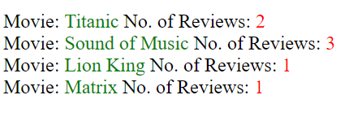

Exercise 3 (25 pts)
Now, you should provide one more stat when you click the link on showMovieStats.php page. The stat should show the movie (s) with the most no. of reviews.
The output should be as below:
Edit the showMovieStats.php file and add one more query (follow the comment lines in the file) to find the name(s) of movie(s) with maximum no. of reviews

